WELS Mentor Forum
4-21-12
The Grace Center
9:00 a.m. – noon

Connecting: Coaching Partners Reflecting on Communication Skills
Purpose: To revisit/reflect on mentor language.

Review: Agenda and Norms for Our Community of Practice

Learning: Develop Skills in Partnership Conversations
Purpose: To support on-going communication with principal/mentor/new
teacher.

Learning: Introduce Mentor Standards and Growth Accountability
Purpose: Compare mentor standards and teaching standards for continued
growth and accountability.

Managing: Reminders:
- Mentor Accountability Logs (MAL) due the beginning of each month
- TBD NTI Seminar July or August
- October 25, 2012 WLSTC Wisconsin Lutheran High School
- WELS NTI StEM Update
- WELS NTI Mentor Selection Criteria Update

Closure: Reflect, Action and Evaluation
Purpose: To move to action in goal setting as mentors.

Scavenger Hunt

Collect and sort sentence stems into mentor language categories. Networking
is encouraged.

Paraphrasing | Clarifying | Mediational  Questions | Non-Judgmental  Response/Suggestions
Objectives

Objective: To connect with mentor language

Mentor Standard: Engages, supports, and advances the professional learning
of each teacher.
- Uses reflective conversation skills to engage a teacher in collaborative problem solving, and reflective thinking to promote self-directed learning

Objective: To review, reflect on triad conversation

Mentor Standard: Creates and maintains collaborative and professional
partnerships to support teacher growth

- Understands a teacher’s school and community and builds relationships with school and community members to foster the teacher’s success and student achievement

Objective: To engage in mentor standards and elements

Mentor Standard: Reflects on mentoring practice and program

Possible Questions to Principal

- Is there any way I can support the….?
- So what direction to the teachers has been given about________?
- Would it be possible for the PLC team to meet as a group?
- Have you had the opportunity to (observe) or _________________?
- Is there ___________that we can get for him/her?
- May I ask how that was addressed?
- Is there some way I could support you?
- What might be a question a teacher might have?
- Might we meet as a triad?

Santa Cruz/Silicon Valley New Teacher Project, January 9, 2012

Suggested Triad Conversation Protocol

Pre-Planning (teacher and mentor)
- Identify any support the new teacher may need from the principal
- Identify any concerns the new teacher may have about the relationship with the principal
- Select/identify any artifacts, student work or student data to bring
- Create outcomes for the meeting
- Select time, place and scheduling options for the meeting
- Clarify roles

Opening
- Express appreciation for the meeting
- Clarify roles
- Co-develop agenda, identify outcomes from both parties
- Determine length of meeting
- Establish confidentiality

Triad Conversation
- Discuss each agenda topic
- Check for understanding

Next Steps
- Identify next steps
- Determine each member’s responsibilities
- Determine timelines for each step
- Determine method of follow up
Closure
- Thank everyone
- Informally debrief (i.e. mentor checks in with each member regarding what worked and elicits suggestions for future conversations
Post Conversation
- What worked?
- What was challenging?
- What are possible next steps for future triad conversations?
- What support is needed?

Triad Conversation Planning/Note Taking Tool
Date: ___________________________________________________________
Objective: ______________________________________________________________________________

What’s working: | Focus—Challenges—Concerns:
Principal’s Next Steps: | New Teacher’s Next Steps/Mentor’s Next Steps:

Next meeting:________________________________________________________

Focus: ________________________________________________________________

Adapted from NTC 2008

Triad Post Conversation Reflections (teacher and mentor)
Date: ___________________________________________________________
Objective: ______________________________________________________________________________

What worked well? (How did I (mentor/teacher) contribute to the conversation? | What was challenging? (Was there anything that I did that pulled us off focus? Are there any unspoken issues that still need to be surfaced?)
What are possible next steps for future triad conversations? (How might I (mentor) support the teacher or administration during our next conversation? How might I (teacher) articulate my concerns?) | What support is needed? (What do I need in order to complete our agreed upon next steps? How can I (mentor) support the teacher in completing next steps?)

Next meeting:________________________________________________________

Focus: ________________________________________________________________

Adapted from NTC 2008 and Santa Cruz/Silicon Valley NTP 2012

Triad Post Conversation Reflections (teacher and mentor)
Date: ___________________________________________________________

What worked well? | What was challenging?
What are possible next steps for future triad conversations? | What support is needed?

Adapted from NTC 2008 and Santa Cruz/Silicon Valley NTP 2012



States, provinces, and nations need to recognize that a combination of change agents is essential for success. If teachers are the most significant factor in student success, and principals are second, then coaches are third. All three, working in coordinated teams, will be required to bring about deep change. The work of coaches is crucial because they change the culture of the school as it relates to instructional practice.

Coaches as System Leaders by Michael Fullan and Jim Knight
Educational Leadership, October 2011, Volume 69, Number 2,
pp. 50-53.



3-2-1

3 – People I need to communicate to and enlist
as advocates:

2 – Next steps to put your plan into action:

1 – Question I need answered to move forward:
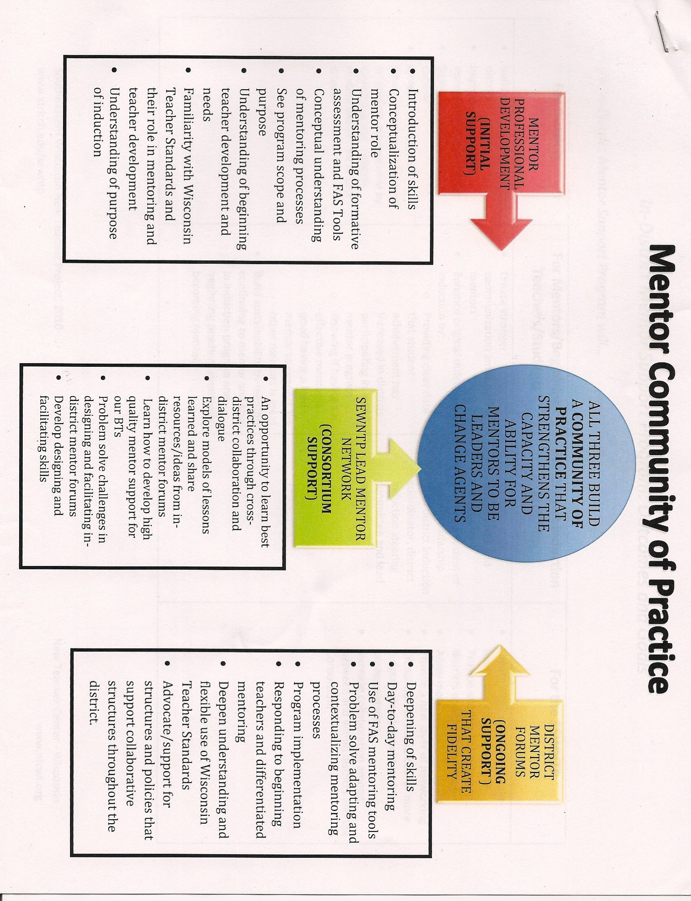
The next pages would be:
In-District Mentor Support Program Outcomes and Goals
From MAGA:
NTC Mentor Formative Assessment Cycle p.6
Mentor Standards p. 17
Mentor Strategies and Topics pp. 12-13
Mentor Self-Assessment Summary p. 29
Mentor CAL ncr forms

Reflection

MAGA is: | MAGA is not:
A service AND a product | Just a product
Designed to promote mentor growth  and accountability | An evaluation system for mentors
A menu of options that takes into  account program context and  evolution | Meant to be implemented totally  and immediately

Consider one or two personal goals you want to pursue as a mentor.

Adapted from New Teacher Center 2008©

Mentor Forum Evaluation
Date: ________________
In what ways did the Mentor Forums support you this year? (Aug 1- principal/new teacher/mentor gathering/BT binder; Oct 27- WLSTC greet/meet/develop handbook; Feb 25- triad conversations; April 21-mentor language/standards)

What were the most valuable features of the Mentor Forums?

What would you change, or what suggestions do you have to improve the Mentor Forums?

In what ways did CLS and the lead mentors support your work with beginning teachers?

What would you change, or what suggestions do you have regarding CLS’s or lead mentors support for your work?

Adapted from NTC, 2004
Language Stems for Scavenger Hunt

So,……………………

In other words…

What I’m hearing, then…

I’m hearing many things…

As I listen to you I’m understanding….

Would you tell me more about…?

Let me see if I understand…

I’d be interested in hearing more…

So, are you saying…?

Tell me what you mean when you…

It would help me understand if you give me an example…

What’s another way you might…?

What would it look like if…?

When have you done something like this before…?

How did you decide…?

What do you think…?

I’m really looking forward to…

A couple of things to keep in mind are…

What I know about ________ is…

Because you want ______, something you might consider trying is…or…

Some teachers I know have tried a couple different things in this situation and maybe one might work for you….

A few possibilities are….Which one might work for you?

What did you do to make the lesson so successful?

How do you think the lesson went and why?

