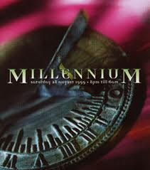

Mentoring in the Millennial
Mentor Forum
Wednesday, February 1st, 2012
4:15-5:15
KMS Room E12
(Gr. 6 hall/Kim Monday’s room)
R.S.V.P. to Danielle Goodman/Human Resources Dept., District Office, by January 30, 2012

Connecting

- Generation Types
Kim Monday
Learning

- Jigsaw article: Tune in to What the New Generation of Teachers Can Do
- Summarize implications for mentoring (including summary of attributes)
- Connections-Experiential and with students
Bruce Endlich

Managing

- Pre-view upcoming SEWNTP classes and events
- Reminder: (Mentor and Teacher Logs)
Lori Pfeiffer & Kim Monday

Closing

- Personal Reflection and Next Steps (using CAL)
Lori Pfeiffer

