SEWNTP Lead Mentor Forum

August 16, 2013

1:00pm – 3:00pm

Connecting: | Across District Partner Activity: Analyze your role as Lead Mentors in your district and SEWNTP Network  Purpose: to understand their role and purpose of their in-district forums, and begin to connect to one and another to build community
Review: | Agenda & Norms for Our Community of Practice  Wiki Expectations
Learning: | Reflect on Group Meeting Experiences  Purpose: To connect with one another and to identify key components of successful meetings that promotes the on-going implementation of mentor skills and strategies.
Learning: | Exploring Learning Topics for District Mentor Forums:  Purpose: To begin to draft a scope and sequence for district mentor forums
Managing & Save the Dates: | Our Next Meeting: October 22nd 4:30-6:30  Urban Seminar, August 29th & Sept. 12th, 26th, October 10th 5:00-7:30  COP Seminars, Sept. 16th & Sept 19th and Oct. 3rd & 14th 5:00-7:00  EDUC 584 Writing the PDP, October 7th, 14th, 21st 5:00-8:00  Common Core Standards September 30th 5:00-7:00
Closure: | 3-2-1 Reflection & Evaluation  Purpose: To move from thought to action in regard to an upcoming district mentor forum.

SEWNTP Vision Statement
Students' needs are met by effective and confident teachers who grow professionally through collaborative network of induction. This network will transform and sustain the quality of leadership and education one person at a time.

The Southeastern Wisconsin New Teacher Project (SEWNTP) Mission Statement
To accelerate new teacher effectiveness and teacher leadership by leveraging the power of collaboration to create and sustain comprehensive systems of induction, resulting in improved student learning
Induction Standard:
Mentor Professional Development and Learning Communities

Element: Program leaders design and implement a mentor learning community for professional learning, problem-solving, and collaborative inquiry.  - What are the goals and outcomes for mentor professional learning?  - When, how, and how often are mentors brought together for collaboration with mentor colleagues to meet their immediate needs and refine their mentoring practice?  - How do we foster shared mentor leadership within their professional learning community? | Element: Program leaders engage mentors in goal-setting and reflection, implementing inquiry action plans, analyzing data of beginning teacher development, field observations, and peer coaching.  - What is the relationship between initial and ongoing professional development and follow-up assessment and support?  - What structures and assistance help mentors be accountable for application of new learning into their mentoring practice?  - What is the relationship between initial and ongoing professional development and follow-up assessment and support?  - How does our program structure and support peer coaching among mentors?  - How do we systematically engage and support mentors in the collection and analysis of their own data of practice?

Q: Reflect on your role as a Lead Mentor; what is the purpose for in-district forms?
Q: Again, consider your role as a lead Mentor; how are you feeling going into the new school year?

Journal Write: use the elements/sub-questions above to guide your reflection

- Across district partner activity: find a partner and share your thoughts as it relates to your role and how you are feeling.
  - Use the elements/sub-questions above and the Next page to support the conversation.
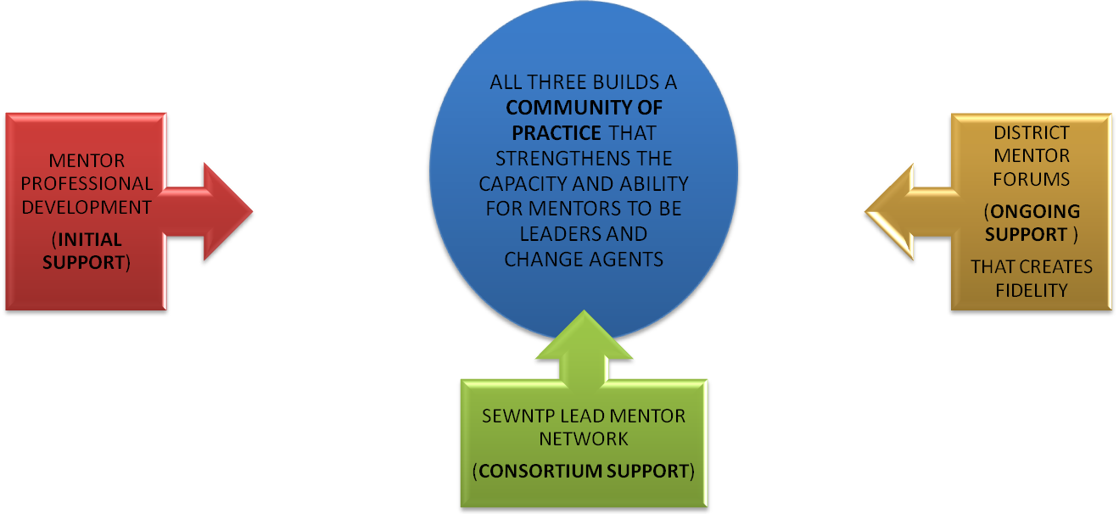
- Introduction of skills
- Conceptualization of mentor role
- Understanding of formative assessment and FAS Tools
- Conceptual understanding of mentoring processes
- See program scope and purpose
- Understanding of beginning teacher development and needs
- Familiarity with Wisconsin Teacher Standards and their role in mentoring and teacher development
- Understanding of purpose of induction

- Deepening of skills
- Day-to-day mentoring
- Use of FAS mentoring tools
- Problem solve adapting and contextualizing mentoring processes
- Program implementation
- Responding to beginning teachers and differentiated mentoring
- Deepen understanding and flexible use of Wisconsin Teacher Standards
- Advocate/support for structures and policies that support collaborative structures throughout the district

An opportunity to learn best practices through cross-district collaboration and dialogue

Explore models of lessons learned and share resources/ideas from in-district mentor forums

Learn how to develop high quality mentor support for our BTs

Problem solve challenges in designing and facilitating in-district mentor forums

Develop designing and facilitating skills

Norms for our community of Practice

      - Collaborative Norms
        - Equity of voice
        - Safety to share all Perspectives
        - Active Listening
        - Confidentiality

Structures That Will Help Us Get There:

      - Shared Learning

      - Structured Protocols

      - Shared Facilitation

      - Transparency of Practice

      - Collecting & Using Data

SEWNTP Lead Mentor Network Wiki Expectations

- Members are expected to post agendas, minutes, ideas, and resources from their in-district mentor forums.

- Members are expected to review the wiki before each lead mentor network meeting to be prepared to ask questions at the meeting.

- Members should bring their laptops to the Lead Mentor Network meetings.

- Members may post on the “Home” discussion board with no obligation for others to respond.

- Katie Kurtz, a SEWNTP Program Coordinator, is available to assist with the wiki. Contact her at kkurtz@stritch.edu

District Name_______________________________ District Mentor Forum Pre-Assessment

Number of Mentors | Number of first year mentors | Number of Mentors with one or more years of experience | # Attended IM | # Attended C&O | # Attended ASW | # Attended  MFE | # Attended  D&P | Attended Other SEWNTP workshops (CCS, DI, MAGA, DITWD, MRD)

Circle the ongoing support do mentors receive in district.
- Annual Orientation
- Number of Forums per school year 9 8 7 6 5 4 3 2 1 0
- This is the 1st 2nd 3rd 4th 5th year for district mentor forums

Circle any of the mentor support your mentors receive.
- Meet regularly with a coaching partner?
- Meet as needed by request with a coaching partner or lead mentor?
- Use a Mentor CAL with another mentor
- Use the Mentor Continuum

2011 New Teacher Profiles:
Number of 1st or 2nd year: ___________
Number of 3rd or 4th year: ___________
Number of Experienced teachers: _______________

Topics at District Mentor Forums in 2012-13:
On the following page fill in Month and times for 2012-13 District Forums

Draft for District Forums SCOPE AND SEQUENCE for 2012-13
Month & TIME | Learning Topic 1 | Learning Topic 2 | Learning Topic 3

3-2-1

………………………………………………………………
3 – People I need to communicate to and enlist as advocates (principals, district administrators, mentors, other stakeholders)

2 – Next steps to put your plan into action

1 – Question I need answered to move forward

